**DESIGN AND FABRICATION OF**

**PORTABLE BENCH GRINDING MACHINE**

**A DESIGN AND FABRICATION PROJECT REPORT**

***Submitted by***

|  |  |
| --- | --- |
| **S.V RAGUL** | **(211420114084)** |
| **S.MUNISHWARAN** | **(211420114070)** |
| **E.RAGHUL** | **(211420114082)** |
| **V.MOTHEESH** | **(211420114068)** |

***In partial fulfilment for the award of the Degree***

***Of***

**BACHELOR OF ENGINEERING**

**IN**

**MECHANICAL ENGINEERING**



**PANIMALR ENGINEERING COLLEGE**

**(Autonomous Institution, Affiliated to Anna University, Chennai)**

**APRIL 2023**

**i**

**PANIMALR ENGINEERING COLLEGE**

**(Autonomous Institution, Affiliated to Anna University, Chennai)**

# BONAFIDE CERTIFICATE

Certified that this project report **“DESIGN AND FABRICATION OF PORTABLE BENCH GRINDING MACHINE”** is the bonafide work of

|  |  |
| --- | --- |
| **S.V RAGUL** | **(211420114084)** |
| **S.MUNISHWARAN** | **(211420114070)** |
| **E.RAGHUL** | **(211420114082)** |
| **V.MOTHEESH** | **(211420114068)** |

Who carried out the design and fabrication project work under my supervision

|  |  |
| --- | --- |
| **Dr. L. KARTHIKEYAN, M.E, M.B.A, Ph.D.,**  **PROFESSOR/HEAD** | **Mr. J. SRINIVAS, M.E.,(Ph.D.),**  **ASSISTANT PROFESSOR** |
| Dept. of Mechanical Engineering  Panimalar Engineering College  Bangalore trunk road,  Varadharajapuram, Nasarathpettai  Poonamalle,Chennai-600123 | Dept. of Mechanical Engineering  Panimalar Engineering College  Bangalore trunk road,  Varadharajapuram, Nasarathpettai  Poonamalle,Chennai-600123 |

Submitted for Anna university project viva-voce held on ………. during

the year ……..

**INTERNAL EXAMINER EXTERNAL EXAMINER**

**ii**

**ABSTRACT**

The grinding machine is used in a variety of sectors to finish work items and provide high-quality surfaces. Grinding is a machining technique that involves the use of an abrasive wheel like cutting tool. In most sectors, grinding is the last step in the manufacturing process. A bench grinder is an appliance that is used to sharpen other tools. Bench grinder has wheels that you can use for grinding, sharpening tools, or shaping some objects. Depending on the types and shape of the wheel, the use of a bench grinder can vary.

This Project focuses on current advancements made possible by the use of Regulators to vary the speed of the motor to reduce the power consumptions and to avoid the vibrations created while machining some workpieces. Dimmer is user to vary the speed of the rotation of the shaft resulting in the variation of the speed and the variation of speed is independent and is not fixed to any specific limit.

This project focuses on the portability and mobility of the machine by moving the machine from one place to another place by easy methods. By reducing the total weight of the machine the mobility of the machine increases. The addition of wheels to the base of the machine further helps in the movement of the machine from one place to another.

**iii**

**ACKNOWLEDGEMENT**

At the outset we would like to express our gratitude to our beloved respected **Chairman, Dr.Jeppiaar,** Our beloved correspondent and Secretary **Mr.P.Chinnadurai M.A., M.Phil., Ph.D.,** and our esteemed director for their support.

We would like to express thanks to our Principal, **Dr. K. Mani M.E., Ph.D.,** for having extended his guidance and cooperation.

We would also like to thank our **Head of the Department**, **Dr.L.Karthikeyan M.E., Ph.D., professor, Department of Mechanical Engineering** for his encouragement.

Personally we thank **Mr. Mr. J. SRINIVAS, M.E., (Ph.D.), Assistant Professor in Department of Mechanical Engineering** for the persistent motivation and support for this project, who at all times was the mentor of germination of the project from a small idea.

We express our thanks to the project coordinators **Mr.Dhanasekar M.E., Assistant professor in Department of Mechanical Engineering** for the Valuable suggestions from time to time at every stage of our project.

Finally, we would like to take this opportunity to thank our family members, friends, well-wishers who have helped us for the successful completion of our project.

We also take the opportunity to thanks all faculty and non-teaching staff members to our department for their timely guidance to complete our project.

**iv**

|  |  |  |  |  |
| --- | --- | --- | --- | --- |
| **TABLE OF CONTENT** | | | | |
|  |  |  |  |  |
| **CHAPTER NO.** | **TITLE** | | | **PAGE NO.** |
|  |  |  |  |  |
|  | **ABSTRACT** | |  | **iii** |
|  |  |  |  |  |
|  | **LIST OF FIGURES** | | |  |
|  | **LIST OF TABLES** | | |  |
|  |  |  |  |  |
| **1** | **INTRODUCTION** | | | **1** |
|  | 1.1 | GRINDING | | 1 |
|  | 1.2 | PROCESS | | 3 |
|  |  | 1.2.1 | CREEP-FEED GRINDING | 3 |
|  |  | 1.2.2 | HIGH-EFFICIENCY DEEP GRINDING | 4 |
|  |  | 1.2.3 | ULTRA-HIGH SPEED GRINDING | 5 |
|  | 1.3 | TYPES OF GRINDING | | 5 |
|  |  | 1.3.1 | CYLINDRICAL GRINDING | 5 |
|  |  | 1.3.2 | SURFACE GRINDING | 7 |
|  |  | 1.3.3 | INTERNAL GRINDING | 8 |
|  |  | 1.3.4 | CENTERLESS GRINDING | 9 |
|  |  | 1.3.5 | CONTOUR GRINDING | 10 |
|  |  | 1.3.6 | GEAR GRINDING | 11 |
|  |  | 1.3.7 | THREAD GRINDING | 12 |
|  | 1.4 | BENCH GRINDING | |  |
|  |  | 1.4.1 | TYPES OF BENCH GRINDING | 14 |
|  |  | 1.4.2 | AUTOMOTIVE BENCH GRINDER | 14 |
|  |  | 1.4.3 | WOOD WORKING BENCH GRINDER | 14 |
|  |  | 1.4.4 | ADVANTAGES & DIS-ADVANTAGES | 15 |

**v**

|  |  |  |  |  |  |
| --- | --- | --- | --- | --- | --- |
| **2** | **LITERATURE REVIEW** | | | | 16 |
|  |  | | |
| **3** | **FEATURES AND INNOVATIONS** | | | | 26 |
|  | 3.1 | ABRASIVE WHEELS | | | 26 |
|  |  | 3.1.1 | TYPES OF ABRASIVE WHEELS | | 31 |
|  |  | 3.1.2 | ALUMINIUM OXIDE WHEEL | | 31 |
|  |  | 3.1.3 | SILICONE CARBIDE WHEEL | | 32 |
|  | 3.2 | REGULATORS | | | 33 |
|  |  | 3.2.1 | PRINCIPLE OF REGULATOR | | 34 |
|  |  | 3.2.2 | ADVANTAGES OF REGULATOR | | 34 |
| **4** | **CALCULATIONS OF MACHINE** | | | |  |
|  | 4.1 | BENCH GRINDING MOTOR | | | 35 |
|  | 4.2 | SUPPORTING BASE | | | 37 |
|  | 4.3 | GRIT SIZE OF GRINDING WHEEL | | | 38 |
| **5** | **CONCLUSION** | | | | 40 |
| **6** | **REFERENCE** | | | | 42 |

**vi**

|  |  |  |
| --- | --- | --- |
|  |  |  |
| **FIGURE NO.** | **TITLE** | **PAGE NO.** |
|  |  |  |
| 1.1 | BLOCK DIAGRAM OF CYLINDRICAL GRINDING | 4 |
| 1.2 | BLOCK DIAGRAM OF SURFACE GRINDING | 5 |
| 1.3 | BLOCK DIAGRAM OF INTERNAL GRINDING | 6 |
| 1.4 | BLOCK DIAGRAM OF CENTRELESS GRINDING | 7 |
| 1.5 | CONTOUR GRINDING | 8 |
| 1.6 | GEAR GRINDING | 8 |
| 1.7 | BLOCK DIAGRAM OF THREAD GRINDING | 9 |
| 1.8 | BLOCK DIAGRAM OF BENCH GRINDER | 10 |
| 3.1 | GRINDING WHEELS | 19 |
| 3.2 | ALUMINIUM OXIDE GRINDING WHEEL | 20 |
| 3.3 | SILICON CARBIDE GRINDING WHEEL | 21 |
| 3.4 | CIRCUIT DIAGRAM OF REGULATOR | 22 |
| 4.1 | BENCH GRINDING MOTOR | 23 |
| 4.2 | SUPPORTING BASE | 24 |

**vii**

|  |  |  |
| --- | --- | --- |
|  | **LIST OF TABLES** |  |
|  |  |  |
| **TABLE NO.** | **TITLE** | **PAGE NO.** |
|  |  |  |
| 4.3 | GRIT SIZE OF GRINDING WHEEL CHART | 25 |
| 4.4 | GRIT VALUES AND THEIR RESPECTIVE SIZE | 26 |

**viii**

**CHAPTER 1**

**INTRODUCTION**

* 1. **GRINDING:**

Grinding is a type of abrasive machining process which uses a [grinding wheel](https://en.wikipedia.org/wiki/Grinding_wheel) as cutting tool.

A wide variety of machines are used for grinding, best classified as portable or stationary:

* Portable [power tools](https://en.wikipedia.org/wiki/Power_tool) such as angle grinders, [die grinders](https://en.wikipedia.org/wiki/Die_grinder) and [cut-off saws](https://en.wikipedia.org/wiki/Abrasive_saw)
* Stationary [power tools](https://en.wikipedia.org/wiki/Power_tool) such as [bench grinders](https://en.wikipedia.org/wiki/Bench_grinder) and [cut-off saws](https://en.wikipedia.org/wiki/Abrasive_saw)
* Stationary [hydro-](https://en.wikipedia.org/wiki/Hydropower) or [hand-powered](https://en.wikipedia.org/wiki/Human_power) [sharpening stones](https://en.wikipedia.org/wiki/Grindstone_(tool))

Milling practice is a large and diverse area of [manufacturing](https://en.wikipedia.org/wiki/Manufacturing) and [toolmaking](https://en.wikipedia.org/wiki/Tool_and_die_maker). It can produce very fine finishes and very accurate dimensions; yet in mass production contexts, it can also rough out large volumes of metal quite rapidly. It is usually better suited to the machining of very [hard](https://en.wikipedia.org/wiki/Hardness) materials than is "regular" machining (that is, cutting larger chips with cutting tools such as [tool bits](https://en.wikipedia.org/wiki/Tool_bit) or [milling cutters](https://en.wikipedia.org/wiki/Milling_cutter)), and until recent decades it was the only practical way to machine such materials as hardened steels. Compared to "regular" machining, it is usually better suited to taking very shallow cuts, such as reducing a shaft's diameter by half a [thousandth of an inch](https://en.wikipedia.org/wiki/Thousandth_of_an_inch) or 12.7 [μm](https://en.wikipedia.org/wiki/Micrometre).

Grinding is a subset of cutting, as grinding is a true metal-cutting process. Each grain of abrasive functions as a microscopic single-point cutting edge (although of high negative [rake angle](https://en.wikipedia.org/wiki/Rake_angle)), and shears a tiny chip that is analogous to what would conventionally be called a "cut" chip (turning, milling, drilling, tapping, etc.) However, among people who work in the machining fields, the term *cutting* is often understood to refer to the macroscopic cutting operations, and *grinding* is often mentally categorized as a "separate" process. This is why the terms are usually used separately in shop-floor practice.

**1**

Grinding is a method of reducing the size of hard materials or sharpening tools, generally accomplished in several stages. To produce desired fineness of end products, grinding is done after crushing. For example, through crushing the mineral ore to below a certain size and finishing by grinding it into powder, the ultimate fineness depends on the fineness of dissemination of the desired mineral.

Grinding can be done wet or dry, depending on the process in use, but for dry grinding the materials first may need to be dried in cylindrical, rotary dryers.

Many machines are used for grinding, including:

* Hand-cranked knife-sharpening stones (grindstones)
* Handheld power tools such as angle grinders and die grinders
* Various industrial machines known as grinding machines
* Bench grinders often found in residential garages and basements

Grinding can produce very fine finishes and very accurate dimensions. It is usually better suited to the machining of very hard materials than is "regular" machining.

Property changes due to grinding include:

* Martensitic layer may form on the part, which leads to reduced material strength from micro cracks
* Possible loss of magnetic properties on ferromagnetic materials
* Increased susceptibility to corrosion because of high surface stress

Grinding machines remove material from the work piece by abrasion, which can generate substantial amounts of heat. To cool the work piece so that it does not overheat and go outside its tolerance, grinding machines incorporate a coolant.

**2**

**1.2 PROCESS:**

Selecting which of the following grinding operations to be used is determined by the size, shape, features and the desired production rate.

During the grinding process, the grinding surface of the grinder tool is evenly coated with abrasive. If the material hardness of the grinding tool is lower than that of the workpiece, when the grinding tool and the workpiece move relative to each other under pressure, the abrasive has sharp edges and corners. Some of the particles with high hardness will be pressed into the surface of the lap to produce cutting action (plastic deformation), and some will roll or slide between the grinding tool and the surface of the workpiece to produce slippage (elastic deformation). These particles, like countless cutting blades, produce a small amount of cutting action on the surface of the workpiece, and evenly cut a thin layer of metal from the surface of the workpiece. At the same time, under the action of the grinding pressure, the passivated abrasive particles squeeze the peak points of the processed surface to produce micro-extrusion plastic deformation on the processed surface, so that the workpiece gradually obtains high dimensional accuracy and low surface roughness.

When using abrasives such as chromium oxide and stearic acid, the abrasive and the processed surface of the workpiece have a chemical effect during the grinding process, resulting in a very thin oxide film, which is easily worn off. The grinding process is the process of continuous generation and erasing of oxide film, so many cycles of repetition reduce the roughness of the processed surface.

**1.2.1 CREEP-FEED GRINDING:**

Creep-Feed Grinding was a grinding process which was invented in Germany in the late 1950s by Edmund and Gerhard Lang. Normal grinding is used primarily to finish surfaces. But CFG is used for high rates of material removal, competing with milling and turning as a manufacturing process choice.

**3**

CFG has grinding depth up to 6 mm (0.236 inches) and workpiece speed is low. Surfaces with a softer-grade resin bond are used to keep workpiece temperature low and an improved surface finish up to 1.6 μm Rmax.

CFG can take 117s to remove 1 in3 (16 cm3) of material. Precision grinding would take more than 200 s to do the same. CFG has the disadvantage of a wheel that is constantly degrading, requires high spindle power (51 hp or 38 kW), and is limited in the length of part it can machine.

To address the problem of wheel sharpness, continuous-dress creep-feed grinding (CDCF) was developed in 1970s. The wheel is dressed constantly during machining in CDCF process and keeps the wheel in a state of specified sharpness. It takes only 17 s to remove 1 in3 (16 cm3) of material, a huge gain in productivity. 38 hp (28 kW) spindle power is required, with a low to conventional spindle speeds. The limit on part length was erased.

**1.2.2 HIGH-EFFICIENCY DEEP GRINDING:**

High-Efficiency Deep Grinding is another type of grinding. This process uses plated super abrasive wheels. These wheels never need dressing and last longer than other wheels. This reduces capital equipment investment costs. HEDG can be used on long part lengths and removes material at a rate of 1 in3 (16 cm3) in 83 s. HEDG requires high spindle power and high spindle speeds.

Peel grinding, patented under the name of Quickpoint in 1985 by [Erwin Junker](https://en.wikipedia.org/wiki/Erwin_Junker) Maschinenfabrik, GmbH in Nordrach, Germany, uses a thin super abrasive grinding disk oriented almost parallel to a cylindrical workpiece and operates somewhat like a lathe turning tool.

**4**

**1.2.3 ULTRA-HIGH SPEED GRINDING:**

Ultra-High Speed Grinding (UHSG) can run at speeds higher than 40,000 fpm (200 m/s), taking 41 s to remove 1 in3 (16 cm3) of material, but is still in the research and development (R&D) stage. It also requires high spindle power and high spindle speeds.

**1.3 TYPES OF GRINDING:** Some of the various grinding methods are:

* Cylindrical grinding.
* Surface grinding.
* Internal grinding.
* Centreless grinding.
* Contour grinding.
* Gear grinding.
* Thread grinding.

**1.3.1 CYLINDRICAL GRINDING:**

Cylindrical Grinding is often called Enken, using either a cylindrical grinding machine or a universal grinding machine. Both the cylindrical workpiece and the wheel are rotated and the outer periphery of the workpiece is machined.

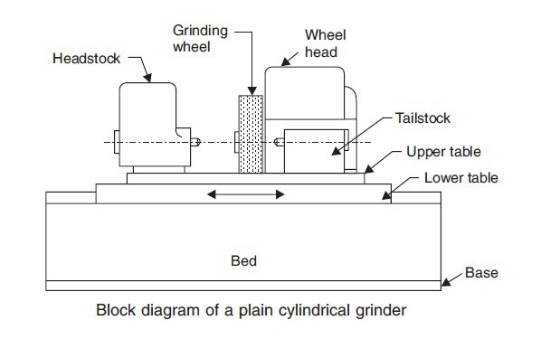The various grinding methods include straight cylindrical, taper, end face, and total shape grinding. Similar to surface grinding, it is a general grinding method

Figure 1.1 block diagram of cylindrical grinding

**5**

Cylindrical grinding (also called centre-type grinding) is used to grind the cylindrical surfaces and shoulders of the workpiece. The workpiece is mounted on centres and rotated by a device known as a [lathe dog](https://en.wikipedia.org/wiki/Lathe_dog) or centre driver. The abrasive wheel and the workpiece are rotated by separate motors and at different speeds. The table can be adjusted to produce tapers. The wheel head can be swivelled. The five types of cylindrical grinding are: outside diameter (OD) grinding, inside diameter (ID) grinding, plunge grinding, creep feed grinding, and centreless grinding.

A [cylindrical grinder](https://en.wikipedia.org/wiki/Cylindrical_grinder) has a grinding (abrasive) wheel, two centres that hold the workpiece, and a chuck, grinding dog, or other mechanism to drive the work. Most cylindrical grinding machines include a swivel to allow the forming of tapered pieces. The wheel and workpiece move parallel to one another in both the radial and longitudinal directions.

The abrasive wheel can have many shapes. Standard disk-shaped wheels can be used to create a tapered or straight workpiece

Geometry, while formed wheels are used to create a shaped workpiece. The process using a formed wheel creates less vibration than using a regular disk-shaped wheel.

Tolerances for cylindrical grinding are held within ±0.0005 inches (13 μm) for diameter and ±0.0001 inches (2.5 μm) for roundness. Precision work can reach tolerances as high as ±0.00005 inches (1.3 μm) for diameter and ±0.00001 inches (0.25 μm) for roundness. [Surface finishes](https://en.wikipedia.org/wiki/Surface_finish) can range from 2 micro inches (51 nm) to 125 micro inches (3.2 μm), with typical finishes ranging from 8 to 32 micro inches (0.20 to 0.81 μm).

**6**

**1.3.2 SURFACE GRINDING:**

Surface grinding is generally called Heiken or Hiraken, which uses either a vertical axis grinding machine or a horizontal axis grinding machine, with a square table or a circular table, and a straight type wheel or a cup type wheel.

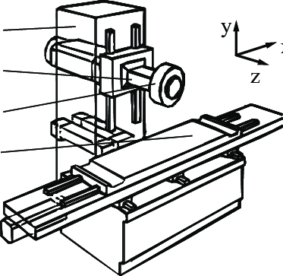The workpiece is fixed on a table and the wheel is rotated at high speed to perform grinding. The double-ended type is equipped with wheels above and below to perform grinding the workpiece in between. Surface grinding is the most common grinding method and is used in a wide range of fields.

Figure 1.2 block diagram of surface grinding

*Surface grinding* uses a rotating abrasive wheel to remove material, creating a flat surface. The tolerances that are normally achieved with grinding are ±2×10−4 inches (5.1 μm) for grinding a flat material and ±3×10−4 inches (7.6 μm) for a parallel surface.

The surface grinder is composed of an abrasive wheel, a work holding device known as a [chuck](https://en.wikipedia.org/wiki/Chuck_(engineering)), either electromagnetic or vacuum, and a reciprocating table.

Grinding is commonly used on [cast iron](https://en.wikipedia.org/wiki/Cast_iron) and various types of [steel](https://en.wikipedia.org/wiki/Steel). These materials lend themselves to grinding because they can be held by the magnetic chuck commonly used on grinding machines and do not melt into the cutting wheel, clogging it and preventing it from cutting.

**7**

Materials that are less commonly ground are [aluminium](https://en.wikipedia.org/wiki/Aluminum), [stainless steel](https://en.wikipedia.org/wiki/Stainless_steel), [brass](https://en.wikipedia.org/wiki/Brass), and [plastics](https://en.wikipedia.org/wiki/Plastic). These all tend to clog the cutting wheel more than steel and cast iron, but with special techniques it is possible to grind them.

**1.3.3 INTERNAL GRINDING:**

Internal grinding is also called Naiken, using an internal grinding machine or a cylindrical grinding machine, or internal grinding equipment attached to a universal grinding machine.

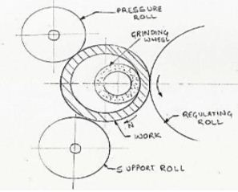The workpiece is fixed and the inner surface of the workpiece is machined with the rotating axle wheel. Grinding may sometimes be performed by rotating the workpiece. Similar to the cylindrical grinding, the grinding method includes taper and end face grinding.

Figure 1.3 block diagram of Internal Grinding

Internal grinding is used to grind the internal diameter of the workpiece. Tapered holes can be ground with the use of internal grinders that can swivel on the horizontal.

**8**

**1.3.4 CENTRELESS GRINDING:**

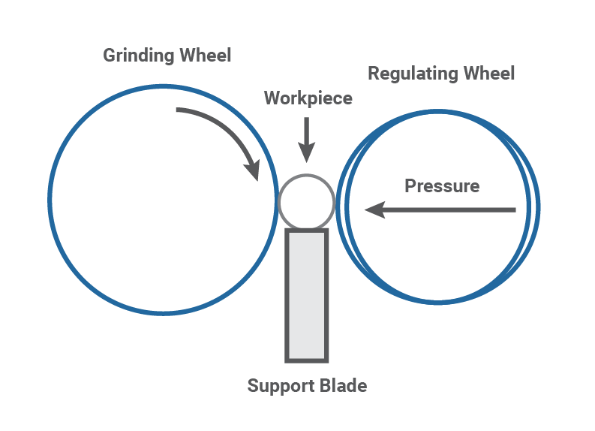 Centreless grinding is also called Shinnashi grinding, and processes the outer periphery of a cylindrical workpiece using a centreless grinding machine. A workpiece is supported between a fixed blade and a rotating adjusting wheel and a grinding wheel. The rotation and feed of the workpiece are then adjusted by rotation of the adjusting wheel to grind the outer circumference of the workpiece. Centreless grinding requires neither a centre hole in the workpiece nor the workpiece’s installation on nor removal from the grinding machine. These advantages make it suitable for mass production.

Figure 1.4 block diagram of centreless grinding

When the workpiece is supported by a blade instead of by centres or chucks. Two wheels are used. The larger one is used to grind the surface of the workpiece and the smaller wheel is used to regulate the axial movement of the workpiece. Types of centreless grinding include through-feed grinding, in-feed/plunge grinding, and internal centreless grinding.

**9**

**1.3.5 CONTOUR GRINDING:**

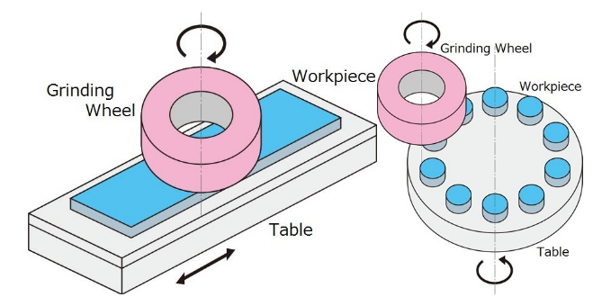 Contour grinding is also called Narai grinding, a process that machines a workpiece into an arbitrary shape using a profile grinding machine, etc.

Figure 1.5 contour grinding

Contour grinding is widely used in machining of different types of curved parts with contour surfaces, such as precision tools and molds. Grinding wheel wear has a crucial influence on the contour accuracy. As a typical processing method, optical projection is used to enlarge the actual contour of the workpiece, and the projected contour is optically magnified and compared with the theoretical contour placed on the projection screen beforehand. In the machining process, the workpiece keeps still and the grinding wheel conducts the feeding movement. The workpiece contour usually needs to be segmented to fit the projection screen. Therefore, multiple theoretical contour templates need to be superimposed on the projection screen and the worktable needs repeated positioning to achieve the piecewise projection of the workpiece contour. So the relative errors between actual and theoretical contour mainly caused by grinding wheel wear can be visually inspected. But the contour image cannot be automatically analyzed to quantify the contour errors, which results in low efficiency and manual dependence.

**10**

**1.3.6 GEAR GRINDING:**

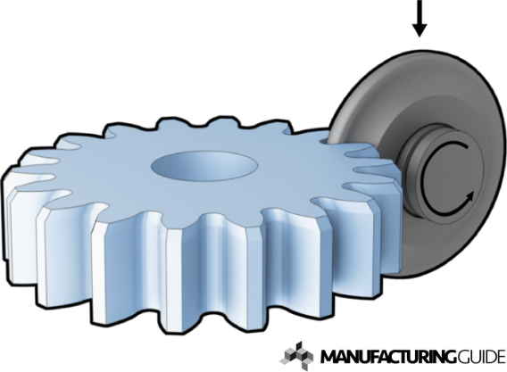 Gear grinding is also called Haken, a process of shaping teeth such as gears using a gear grinding machine. General whetstones are mainly used, which are molded with the dresser (rotary dresser) using diamond abrasive grains. Gear grinding is used to remove surface materials on a gear blank through abrasion. Abrasion is conducted through rubbing of a rough surface against a piece of metal at high speeds to scrape away the material that is not needed in the gear.

Figure 1.6 gear grinding

Gear teeth can be created entirely by grinding, completely by cutting, or by first cutting and then grinding to the expected dimensions. Normally, gear grinding process is done after gear has been cut and heat-treated to high hardness. Grinding is essential for parts above 350 HB (38 HRC) where cutting becomes very hard. Teeth produced by grinding are normally those of definite pitch, where the number of metal extracted is very small. Also, **grinding of gears** becomes the method of choice in the matter of fully hardened steels, where it may be hard to have the heat-treat deformity of gear within fair limits. Lastly, in a few cases, medium-hard gears that could be achieved by cutting are filed to save costs on costly cutting tools such as hobs, shapers or shaving cutters, or to gain the desired surface finish or efficiency on a difficult-to-manufacture gear.

**The two basic techniques for gear grinding are**

* Form grinding (non-generating) and
* Generation grinding

**11**

Form grinders utilize a disc wheel to grind both facets of the space between two gear teeth, and have an involute figure dressed into the top of the wheel; a generating grinding ring, on the other hand, is straight. The major problem of **grinding gears** is their cost. Because materials must be excluded in small supplements when grinding as compared to cutting, the former is more costly. Also, ground gears draw more inspection than cut gears and may include both magnetic particle review as well as macro etching with dilute nitric acid.

In gear manufacturing, **gear grinding** is a finishing method which utilizes abrasive wheels to exclude small variations on gear teeth. It is generally known to be the most perfect way to end a high precision gear, giving a more accurate tooth finish than gear cutting.

Due to their specific gear geometry, ground gears offer great meshing effectiveness and stable operation, working more quietly and consuming more evenly than cut gears. They can also manage greater loads and are helpful when large amounts of energy are required. For these purposes, they are often seen in equipment that requires high performance and safety.

**1.3.7 THREAD GRINDING:**

Thread grinding is a process of forming the thread using a teeth thread grinding machine. Threads are ground by contact between a rotating workpiece and a rotating grinding wheel that has been shaped to the desired thread form.

The grinding wheel that is shaped like the [threads](https://www.manufacturingguide.com/en/ordlista/threads) cross section rotates and polishes the workpiece while it slowly rotates and moves axially. Often the process is supported by a [cutting fluid](https://www.manufacturingguide.com/en/ordlista/cutting-fluid). There are various methods for generating screw threads. The method for any one application is chosen based on constraints—time, money, degree of precision needed (or not needed), what equipment is already available, what equipment purchases could be justified based on resulting unit price of the threaded part.

**12**

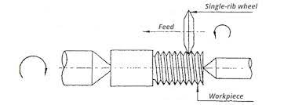In addition to rotation, there is relative axial motion between the wheel and the workpiece to match the pitch of the thread being ground.

Figure 1.7 block diagram of thread grinding

**1.4 BENCH GRINDING:**

A bench grinder is a [benchtop](https://en.wikipedia.org/wiki/Workbench) type of [grinding machine](https://en.wikipedia.org/wiki/Grinding_machine) used to drive [abrasive wheels](https://en.wikipedia.org/wiki/Grinding_wheel). A pedestal grinder is a similar or larger version of grinder that is mounted on a [pedestal](https://en.wiktionary.org/wiki/pedestal#Noun), which may be bolted to the floor or may sit on [rubber feet](https://en.wikipedia.org/wiki/Bushing_(isolator)). These types of grinders are commonly used to hand [grind](https://en.wikipedia.org/wiki/Grinding_(abrasive_cutting)) various [cutting tools](https://en.wikipedia.org/wiki/Cutting_tool_(machining)) and perform other rough grinding.[[1]](https://en.wikipedia.org/wiki/Bench_grinder#cite_note-KrarEtAl2003-1)

Depending on the bond and grade of the grinding wheel, it may be used for sharpening cutting tools such as [tool bits](https://en.wikipedia.org/wiki/Tool_bit), [drill bits](https://en.wikipedia.org/wiki/Drill_bit), [chisels](https://en.wikipedia.org/wiki/Chisel), and [gouges](https://en.wikipedia.org/wiki/Chisel#Gouge). Alternatively, it may be used to roughly shape metal prior to [welding](https://en.wikipedia.org/wiki/Welding) or fitting.

A [wire brush](https://en.wikipedia.org/wiki/Wire_brush) wheel or buffing wheels can be interchanged with the grinding wheels in order to clean or [polish](https://en.wikipedia.org/wiki/Polishing_(metalworking)) workpieces. Stiff buffing wheels can also be used when [deburring](https://en.wikipedia.org/wiki/Burr_(edge)#Deburring) is the task at hand.

Some buffing machines (buffers) are built on the same concept as bench grinders except for longer housings and arbours with buffing wheels instead of grinding wheels.

Bench grinders are standard equipment in [metal fabrication shops](https://en.wikipedia.org/wiki/Metal_fabrication) and [machine shops](https://en.wikipedia.org/wiki/Machine_shop), as are handheld grinders (such as [angle grinders](https://en.wikipedia.org/wiki/Angle_grinder) and [die grinders](https://en.wikipedia.org/wiki/Die_grinder)).

**13**

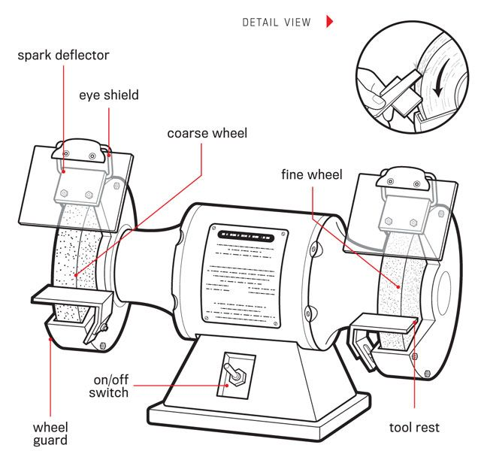

Figure 1.8 block diagram of bench grinder

**1.4.1 TYPES OF BENCH GRINDERS:**

The types and categorization of bench grinders differs from the working conditions and the specifications of the bench grinders. Some of the types of bench grinders are:

* Automotive bench grinders
* Wood working bench grinders

**1.4.2 AUTOMOTIVE BENCH GRINDER:**

An automotive bench grinder is mainly used for various metal equipment and a whole range of cutting tools. It is quite popular, and it is designed to be extremely stable and balanced, especially if you do a lot of repetitive tasks. Besides, it does not require much adjustment before and after use.

It is often used to grind and polish engine parts, door hinges, and much more.

**1.4.3 WOODWORKING BENCH GRINDER:**

The woodworking bench grinder is used for sharpening tools and generally smoothing cutting edges.

**14**

It is also used to grind and sand wood hence the name woodworking.In addition, this grinder runs at a slower speed than other types of grinders allowing you to work with the required degree of precision.

### **1.4.4 ADVANTAGES OF GRINDING OPERATION**:

* This can produce a high surface finish with accurate can obtain.
* This can machine hard materials.
* This operation can be done with less pressure applied on work.
* It can obtain highly accurate dimensions.
* It can work at high temperature also.
* Speed of cutting can be done by this process.
* In grinding abrasive particles, they are self-sharpened action.
* This can operate for complex things also.
* Smooth surface can obtain

### **DISADVANTAGES OF GRINDING OPERATIONS:**

* Required tool is high cost.
* Process is also a costly one.
* It cannot remove the high amount of material, it only removes a little amount.
* For removing the required amount from work it consumes more time.
* You should work carefully, because imperfect contact may lead to damages.

**15**

**CHAPTER 2**

**LITERATURE REVIEW**

* Wegener, K., Bleicher, F., Krajnik, P., Hoffmeister, H.W. and Brecher, C., 2017. Recent developments in grinding machines. CIRP Annals, *66*(2), pp.779-802.- [Grinding](https://www.sciencedirect.com/topics/engineering/grinding-machining) is often the final step in the process/manufacturing chain, meaning that no subsequent post-grinding correction of the surface and geometry is performed. This imposes strong requirements on grinding-machine technology and on the understanding of this finalising process. While grinding has unique capabilities it is nevertheless in competition with other machining processes. The evolution of grinding machines is driven by process requirements like accuracy, [MRR](https://www.sciencedirect.com/topics/engineering/material-removal-rate), and subsurface integrity. The regeneration of the tool on the machine with dressing devices is to be regarded as unique for grinding machines, hence a grinding machine always runs two separate processes. The high accuracy of grinding has, in fact, been an obstacle to simply adopting developments from other machining processes.
* Rowe, W.B., Yan, L., Inasaki, I. and Malkin, S., 1994. Applications of artificial intelligence in grinding. *CIRP annals*, *43*(2), pp.521-531.- The application of AI technologies using modern computers and controllers is seen as a way forward to produce higher quality components more efficiently with smaller batch sizes and more frequent changeovers. Users continue to demand better accuracy, surface integrity, and shorter cycle times with reduced operator intervention and increased flexibility. This paper reviews research into the use of AI methods to harness the knowledge and skills required to plan, set-up, operate and control grinding processes. Basic AI concepts are introduced and discussed particularly in the context of application to grinding.

**16**

Two main trends are evidenced in the development of AI technologies in grinding: desktop systems to assist tool and parameter selection and self-optimising systems integrated within the machine controller. It is predicted mat future developments will favour increasing communication between these two levels of control within a CIM environment The development of modular systems which are sufficiently robust to plan, supervise and control abrasive processes requires ongoing research and development.

* Lv, L., Deng, Z., Liu, T., Li, Z. and Liu, W., 2020. Intelligent technology in grinding process driven by data: A review. *Journal of Manufacturing Processes*, *58*, pp.1039-1051. - [Grinding](https://www.sciencedirect.com/topics/engineering/grinding-machining) is a key process in machining, which has direct impact on the accuracy, performance and service life of the finished workpiece. With the rapid development and popularization of computers and information technology, the intelligentization of grinding technology has become an important research topic. Especially with the explosive growth of industry data, grinding process data has become the core element in intelligent manufacturing. To understand the connotation, status quo and development trends of intelligent technology in the grinding process, this paper takes the relationship between grinding process data and intelligent manufacturing as perspective. A research structure of data-driven mode is built in the grinding process, followed by the basic concepts and characteristics of grinding data. Relevant researches that maybe beneficial to the proposed research structure are reviewed in five layers, which include data acquisition layer, data processing and fusion layer, data mining and analysis layer, data representation and evolution layer, and data service layer. Finally, the current data-driven mode and future trends in this field are summarized.
* Pei, Z.J., Fisher, G.R. and Liu, J., 2008. Grinding of silicon wafers: a review from historical perspectives. *International Journal of Machine Tools and Manufacture*, *48*(12-13), pp.1297-1307.

**17**

The majority of semiconductor devices are built on [silicon wafers](https://www.sciencedirect.com/topics/engineering/silicon-wafer). Manufacturing of high-quality silicon wafers involves several machining processes including [grinding](https://www.sciencedirect.com/topics/engineering/grinding-machining). This review paper discusses historical perspectives on grinding of silicon wafers, impacts of wafer size progression on applications of grinding in silicon wafer manufacturing, and [interrelationships](https://www.sciencedirect.com/topics/engineering/interrelationship) between grinding and two other silicon machining processes (slicing and polishing). It is intended to help readers to gain a more comprehensive view on grinding of silicon wafers, and to be instrumental for research and development in grinding of wafers made from other materials (such as gallium arsenide, [germanium](https://www.sciencedirect.com/topics/engineering/germanium), lithium niobate, sapphire, and silicon carbide).

* Zhong, Z.W. and Venkatesh, V.C., 2009. Recent developments in grinding of advanced materials. The International Journal of Advanced Manufacturing Technology, 41, pp.468-480. This article discusses the recent developments in grinding of advanced materials. Eighty-four journal papers published recently are briefly introduced. The topics are advances in grinding of brittle materials, grinding of silicon, dressing/truing of grinding wheels, grinding fluids, grinding of mirrors and vibration-assisted grinding, measuring/monitoring of grinding, optimization of grinding, modelling and simulation of grinding, and size effect. Ductile mode grinding of brittle materials has been and will continue to be an intensive research area because of its increasing industrial applications and academic demands for fundamental understanding of the ductile mode grinding mechanism. Highly precision manufacturing of silicon substrates faces more and more new challenges. Grinding of silicon continues to be a popular research topic. Using lasers to true and dress grinding wheels has attracted great research interest, because it has significant advantages over mechanical processes. Environmentally friendly grinding fluids are increasingly highly demanded. Vibration-assisted grinding is promising.

**18**

Monitoring, modelling and optimization of grinding processes help to understand grinding mechanisms and achieve better grinding performance. The size effect is more prominent in grinding than turning and can be used for obtaining a controlled work-hardening surface layer with higher wear resistance and hardness.

* Doman, D.A., Warkentin, A. and Bauer, R., 2009. Finite element modeling approaches in grinding. International journal of machine tools and manufacture, 49(2), pp.109-116. This article discusses the recent developments in grinding of advanced materials. Eighty-four journal papers published recently are briefly introduced. The topics are advances in grinding of brittle materials, grinding of silicon, dressing/truing of grinding wheels, grinding fluids, grinding of mirrors and vibration-assisted grinding, measuring/monitoring of grinding, optimization of grinding, modelling and simulation of grinding, and size effect. Ductile mode grinding of brittle materials has been and will continue to be an intensive research area because of its increasing industrial applications and academic demands for fundamental understanding of the ductile mode grinding mechanism. Highly precision manufacturing of silicon substrates faces more and more new challenges. Grinding of silicon continues to be a popular research topic. Using lasers to true and dress grinding wheels has attracted great research interest, because it has significant advantages over mechanical processes. Environmentally friendly grinding fluids are increasingly highly demanded. Vibration-assisted grinding is promising. Monitoring, modelling and optimization of grinding processes help to understand grinding mechanisms and achieve better grinding performance. The size effect is more prominent in grinding than turning and can be used for obtaining a controlled work-hardening surface layer with higher wear resistance and hardness.

**19**

* Rowe, W.B., Li, Y., Mills, B. and Allanson, D.R., 1996. Application of intelligent CNC in grinding. Computers in industry, *31*(1), pp.45-60. The application of AI technologies using modern computers and controllers is seen as a way forward to produce higher quality components more efficiently with smaller batch sizes and more frequent changeovers. Users continue to demand better accuracy, surface integrity, and shorter cycle times with reduced operator intervention and increased flexibility. This paper reviews research into the use of intelligent control and optimisation techniques in grinding and propose the incorporation of intelligent techniques into computer numerical controls (CNCs). Two main trends are evidenced in the development of AI technologies in grinding: desktop systems to assist tool and parameter selection and self-optimising systems integrated within the machine controller. It is predicted that future developments will favour increasing incorporation of intelligence into CNC. The development of modular systems which are sufficiently robust to plan, supervise and control abrasive processes requires ongoing research and development.
* Liu, J.H., Pei, Z.J. and Fisher, G.R., 2007. ELID grinding of silicon wafers: a literature review. International Journal of Machine Tools and Manufacture, 47(3-4), pp.529-536. [Silicon wafers](https://www.sciencedirect.com/topics/engineering/silicon-wafer) are the most widely used substrates for fabricating integrated circuits. There have been continuous demands for higher quality silicon wafers with lower prices, and it becomes more and more difficult to meet these demands using current [manufacturing processes](https://www.sciencedirect.com/topics/engineering/production-process). In recent years, research has been done on electrolytic in-process dressing (ELID) [grinding](https://www.sciencedirect.com/topics/engineering/grinding-machining) of silicon wafers to explore its potential to become a viable manufacturing process. This paper reviews the literature on ELID grinding, covering its set-ups, wheel dressing mechanism, and experimental results. It also discusses the technical barriers that have to be overcome before ELID grinding can be used in manufacturing.

**20**

* Zhu, D., Feng, X., Xu, X., Yang, Z., Li, W., Yan, S. and Ding, H., 2020. Robotic grinding of complex components: a step towards efficient and intelligent machining–challenges, solutions, and applications. Robotics and Computer-Integrated Manufacturing, 65, p.101908. Robotic grinding is considered as an alternative towards the efficient and intelligent machining of complex components by virtue of its flexibility, intelligence and cost efficiency, particularly in comparison with the current mainstream manufacturing modes. The advances in robotic [grinding](https://www.sciencedirect.com/topics/engineering/grinding-machining) during the past one to two decades present two extremes: one aims to solve the problem of precision machining of small-scale complex surfaces, the other emphasizes on the efficient machining of large-scale complex structures. To achieve efficient and intelligent grinding of these two different types of complex components, researchers have attempted to conquer key technologies and develop relevant machining system. The aim of this paper is to present a systematic, critical, and comprehensively review of all aspects of robotic grinding of complex components, especially focusing on three research objectives.

For the first research objective, the problems and challenges arising out of robotic grinding of complex components are identified from three aspects of accuracy control, compliance control and cooperative control, and their impact on the machined workpiece geometrical accuracy, surface integrity and machining efficiency are also identified. For the second aim of this review, the relevant research work in the field of robotic grinding till the date are organized, and the various strategies and alternative solutions to overcome the challenges are provided. The research perspectives are concentrated primarily on the high-precision online measurement, grinding allowance control, constant contact force control, and surface integrity from robotic grinding, thereby potentially constructing the integration of “measurement – manipulation – machining” for the robotic grinding system.

**21**

For the third objective, typical applications of this research work to implement successful robotic grinding of [turbine blades](https://www.sciencedirect.com/topics/engineering/blade-turbine) and large-scale complex structures are discussed. Some research interests for future work to promote robotic grinding of complex components towards more intelligent and efficient in practical applications are also suggested.

* Walden, C.H. and Nobles, J., 1989. Machine Shop. Module 3: Bench Work and Material Science. Instructor's Guide. This document consists of materials for an 11-unit course on the following topics: (1) hacksawing; (2) filing and deburring; (3) locating centers for drilling; (4) cutting threads with tap and die; (5) using a hand reamer; (6) pedestal/bench grinder operation; (7) whetting, polishing, and lapping; (8) screw, drill, and tap extraction; (9) arbor press operations; (10) types of materials; and (11) testing and hardening materials. The instructor's guide begins with a list of competencies covered in the module, descriptions of the materials included, an explanation of how to use the materials, and information on how the curriculum guide is packaged. Next is a table that associates individual instructional materials in the units with the competencies they teach. The instructional units follow, each of which may include unit objectives, lesson objectives, lesson plans, references, notes to the teacher, information sheets or outlines, transparency masters, handouts, assignment sheets, job sheets, unit tests, and answers to tests. (CML)
* Kirkpatrick, T. and Sappe, H., 1989. Sheet Metal Contract. Project Report Phase I with Research Findings. This report provides results of Phase I of a project that researched the occupational area of sheet metal, established appropriate committees, and conducted task verification. These results are intended to guide development of a program designed to train sheet metal workers. Section 1 contains general information: purpose of Phase I;

**22**

description of the occupation, including nature of work, working conditions, and related occupations; direction of the occupation, including employment, training and other qualifications, advancement, job outlook, and earnings; program development committee; areas of concern; and State Technical Committee developmental recommendations. Section 2 presents research findings: accreditation and certification; list of typical job titles; and appropriate trade resources and sources, including references and textbooks, audiovisuals, curriculum materials, periodicals, safety manual, shop safety signs, and sources of additional information. A verified occupational duty and task list is comprised of six duties: read blueprints, lay out sheet metal, fabricate mechanical systems, fabricate architectural/roofing sheet metal, fabricate food service sheet metal products, install mechanical systems, and install architectural/roofing sheet metal. Other contents include a tools and equipment list, list of contents of standard tool kit, and staff and facilities recommendations. (YLB)

* Amri, N.I.Q., 2022. The design of bench grinding machine using hard disk. Grinding is an important part of the final machining process. The project has intended to solve the problem faced by consumer that is the vertical wheel making the machine operators uncomfortable and the grinding machine that are using by the student of Faculty of Mechanical Engineering UiTM Bukit Bcsi Campus is a vertical grinder wheel. The objective to make it portable and compact enough to bring anyplace also easy to use and to design and fabricate a bench grinding machine that is in horizontal wheel condition to improve industrial work and for students mechanical engineering. To achieve all the above, many kinds of this method of studies is done, which is methodology research, research component, flowchart as guide to carried out this project, testing and lastly discussion. Based on the analysis and discussion, it can be concluded that bench grinding machine have achieve the objectives that have been discussed.

**23**

* García, E., Sánchez, J.A., Méresse, D., Pombo, I. and Dubar, L., 2014. Complementary tribometers for the analysis of contact phenomena in grinding. *Journal of Materials Processing Technology*, *214*(9), pp.1787-1797. The characterization of friction and tribological phenomena occurring in [grinding](https://www.sciencedirect.com/topics/engineering/grinding-machining) requires reliable experimental input data. Up to now, existing test benches exhibit important limitations. Steep thermal gradients and elastic deformations of both machine structure, and rubbing elements are the main sources of inaccuracy cited in the literature. In this paper, an alternative approach is presented for the study and characterization of contact phenomena in grinding. It consists of two complementary test benches: the On-Machine Test Bench and the High Speed Tribometer. They are designed to overcome the limitations of current grinding experimental studies.

On the one hand, the On-Machine Test Bench enables accurate control of process parameters. This allows assessing the effect of the different grinding mechanisms on process forces, and specific energy. In addition, its configuration avoids steep thermal gradients; consequently, it is possible to obtain stable and accurate temperature measurements that can be directly related to process variables. On the other hand, the High Speed Tribometer enables to isolate adhesive effect because of its predominance. This test bench allows an accurate control of contact pressure and contact area. Then, adhesive phenomena can be characterized and related to process parameters using force and temperature measurements.

Experimental results obtained in both test benches are presented. A wide range of data (forces, specific energy, temperatures, wear…) concerning contact conditions in grinding can be obtained from this complementary approach.

**24**

* Kanematsu, Y. and Satoh, Y., 2011. Influence of type of grinding stone on rail grinding efficiency. *Quarterly Report of RTRI*, *52*(2), pp.97-102.

Rail grinding is a traditional part of maintenance employed to mitigate rail damage such as shelling and corrugation. In order to improve the efficiency of grinding operations in the field, new grinding stones were developed and evaluated in this study. The improvement in grinding capacity of the developed grinding stone compared with the current grinding stone was confirmed, as was its improved grinding performance due to its more moderate impact on rails from a metallographic point of view despite the improved grinding performance. Based on these results, it is expected that the developed grinding stone has the potential to be introduced to field grinding operations.

**25**

**CHAPTER 3**

**FEATURES AND INNOVATIONS**

**3.1 ABRASIVE WHEELS:**

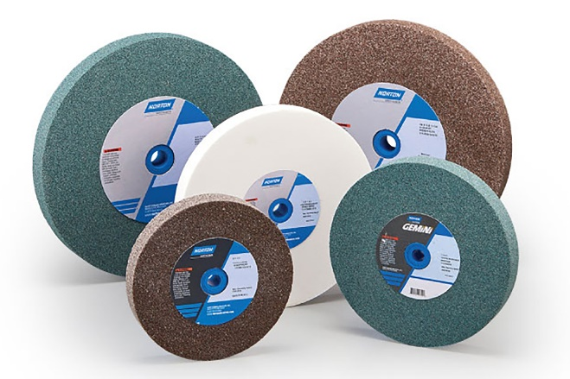 A grinding wheel is basically a precision tool composed of abrasive grains held together by a bonding material. The abrasive grains provide the wheel with its cutting ability which helps in finishing the material to the required dimensional accuracy and surface finish. Material of grinding wheels becomes more important in case of gear grinding due to need of high precision in terms of surface finish and material removal rate (MRR). Al2O3, [SiC](https://www.sciencedirect.com/topics/materials-science/silicon-carbide), and [CBN](https://www.sciencedirect.com/topics/materials-science/cubic-boron-nitride) are the most commonly used abrasives. Synthesis of these abrasives allows accurate control of their form and physical characteristics.

Figure 3.1 grinding wheels

Grinding wheel speed is an important parameter during gear grinding. Increase in grinding wheel speed keeping other parameters constant, reduces grinding forces and roughness, and increases life of redressed grinding wheel and specific energy consumption. Table 7 presents the details of abrasives, grinding wheel speed, and depth of cut for different gear materials.

**26**

**WIRE WHEELS:**

Wire wheels are an extraordinary decision for scratching consumption and rot, dust, slag, weld splatter and other undesirable surface particles with point processors, seat processors or drills. For surface composition, washing and cleaning, weld blending, deburring, and end of tar, erosion, size, or other contamination, wheel brushes offer straight line brushing activity.

Wheel brushes are ideal for use with various sorts of handheld processors, work area processors, mechanical completing hardware or for mounting in an assembling interaction onto a fueled arbour. The Wire wheel is a rough instrument utilized for rust cleaning and paint expulsion.

Different sorts of wire wheel brushes are accessible, yet the gadget choice beginnings with a comprehension of the essential methods of wire wheel: pleated and tied.

**CRIMPED WIRE WHEEL:**

Individual filaments are supported only by one another, creating extra flexibility. [**Crimped Wire Wheels**](https://benchmarkabrasives.com/products/3-mounted-crimped-wire-wheel-carbon-steel-wire) are ideal for work on irregular surfaces, more refined surface finishing, and light- to medium-duty contaminant removal.

The component or workpiece base material dictates which filament sort to settle on, and therefore the filament or wire size may be a feature of the finishing specifications. Another essential to recollect is the mask distance so that producers can prefer short, medium, broad, or extra-large. Narrower brush faces are suitable for uneven textures, corners, and crevices.

[**KNOTTED WIRE WHEEL**](https://benchmarkabrasives.com/collections/steel-wire-products/products/4-standard-twist-knot-wire-wheel-stainless-steel):

[**Knotted wire wheel**](https://benchmarkabrasives.com/collections/steel-wire-products/products/4-standard-twist-knot-wire-wheel-stainless-steel) brushes feature metal wire ties or loops, usually steel or chrome steel. We help vigorous hacking and withstand twisting and movements, which may contribute to exhaustion of the metal.

**27**

Regular or twisted tuft brushes are twisted for around two-thirds of the duration of the filament.

The remaining third gets slightly flared. The loops are often twisted over their entire length for more significant wire sizes and applications that require massive brushing action. Such knotted brushes of the [**Wire Wheel**](https://benchmarkabrasives.com/products/4-standard-twist-knot-wire-wheel-stainless-steel) are classified as cable twists and are often utilized in oil pipelines and oil fields. It is often used for surface painting of narrow channels and grooves and pre-welding preparation of pipes. Unlike crimped wire wheel brushes with a little face, stringer bead brushes have longer trimming to end uneven corner and crevice surfaces.

**STANDARED TWIST KNOT WIRE WHEEL:**

It is made with straight wire filaments twisted together to form more rigid rope- or cable-like pieces—the selection for more aggressive applications requiring higher-impact action and a rougher surface finish.

## **Airway Buffing Wheels**

## At EmpireAbrasives.com, we sell 3 styles of [8” Airway buffing wheels](https://www.empireabrasives.com/airway-buffing-wheels/). They are all made with a 3” center plate and a ⅝” arbor hole. They have been designed to be used on an angle grinder, bench top lathe, polisher/sanding machine, variable speed polisher, and more.

Each of these [buffing wheels](https://www.empireabrasives.com/buffing-polishing-wheels-discs/) are 16-ply, meaning 16 cotton layers are attached to the center plate. They are attached in a special way that creates pleats throughout the entire wheel. These pleats allow for extra airflow during buffing and allows the buffing wheel to run at cooler temperatures protecting the airway buffs from overheating, which can extend the product's life as well as the workpiece.

The main difference you’ll see between each airway buff is the color treatments. Each color signifies a different level of hardness for each wheel.

**28**

The hardness/stiffness of the airway buffs should be considered for which step of the buffing and polishing process you’re on, as well as what metal you are working with.

**Orange Mill Treated** - These are the firmest airway buffs. The stiffness of the orange airway buffing wheels allows them to both cut and color aggressively. These generally work best for the beginning stages of buffing, often using black magic or brown tripoli buffing compound.

**Yellow Mill Treated** - Yellow treated wheels are 15% less stiff than the orange mill treated. While you can use the yellow mill treated airway buff for both color and cutting, it is ideally suited for color with light cutting. You will likely get the best results from this colored airway buff when using green rouge buffing compound.

**Untreated White Domet Flannel** - White airway buffs are the softest and most delicate of our three airway buffs. The white flannel is an ultra plush option for getting an ultra high luster and perfect mirror finish. Unlike the treated counterparts, there is no noticeable stiffness.

The airway buffs are designed for you to use the edge of the buffing wheel for the actual polishing, while evenly applying [buffing compound bars](https://www.empireabrasives.com/buffing-compounds/) as the cutting agent. This method is called **edge buffing** and is commonly used when polishing metal with a buffing wheel or an angle grinder.

This buffing wheel must be used with a specific ventilated flange as to prevent delamination from the steel center. We also recommend always raking your buffing wheels between uses. This will help to prevent compound build up and remove any hardened and burned-on compound from the edges of your wheel. This will help extend the life of your airway buff and help you get more consistent results.

**29**

## **Sisal Buffing Wheels**

At EmpireAbrasives.com, we also carry [sisal buffing wheels](https://www.empireabrasives.com/sisal-buffing-wheels/), another buffing and polishing wheel known for their aggressive cutting capabilities. Sisal buffing wheels are made from cellular fibers formed into a thin cord that the buffing wheel is constructed from. These fibers are known for their high strength foundation in creating binders’ twine, cords, ropes, etc. They are naturally abrasive, and the cellular fibers are also grease absorbing.

Our sisal buffing wheels are all closely stitched with a ¼” stitch spacing and spiral sewn. The hardness of the buff is within the spacing of the stitching.

The ¼” stitching is the most popular especially when you want a hard buff. These buffing wheels will provide both polishing and cutting action. Sisal buffs are often the first buffing wheel used for cutting processes, especially for harder metals like stainless steel or iron. They will also remove things such as: stretcher stains, polishing wheel grit lines, light die marks, orange peel, etc. They are most commonly used for finishing roll formed, drawn, and stamped metals. When combined with cloth, they can cut and finish stampings in a single operation prior to preplating.

It also runs cooler due to the airflow from the center of the buff. Sisal buffing wheels have been designed to be used with a bench grinder, bench polisher, bench top lathe, or buffing machine.

When using a sisal wheel it is common to have to add more buffing compound in short intervals such as every 30 to 60 seconds. If using the sisal wheel in combination with the black compound does not take out your scratches then you will need to do further sanding on your workpiece.

In order to extend the life of the wheels and avoid accumulating hardening compounds, it is recommended that you rake your sisal buffing wheels

**30**

**3.1.1 ALUMINIUM OXIDE WHEEL:**

White Aluminium Oxide Grinding Wheels Are manufactured by using conical shaped aluminium oxide grains with a vitrified white bond, which allows the grains of abrasive to wear off, providing a consistently fresh grinding surface. Generally recommended for grinding materials of high tensile strength, such as stainless steel and tool steels but it can also be used on some high tensile aluminium and bronze alloys. Aluminium Oxide is manufactured in varying qualities.

Figure 3.2 aluminium oxide grinding wheel

Aluminium Oxide is also a cost effective blasting abrasive due to the fact that it can be recycled and reclaimed for multiple passes in a blasting process. Aluminium Oxide is a harder abrasive than most, resulting in less shatter of the particles which results in lower dust levels.

**31**

**3.1.2 SILICONE CARBIDE WHEEL:**

 Silicon carbide is an abrasive used for grinding grey iron, chilled iron, brass, soft bronze and aluminium, as well as stone, rubber and other nonferrous materials. The main advantage of a SiC MOSFET is the low drain-to-source ON-resistance (RDS-ON) — about 300–400 times lower than that of silicon devices with a comparable breakdown voltage — presenting a key desirable feature for designing extraordinarily efficient power electronics equipment and related systems.

Figure 3.3 silicon carbide grinding wheel

Harder than standard aluminium oxide with a very sharp abrasive grain. It is a versatile material, recommended for grinding relatively soft metals such as aluminium or cast iron but can also be used on extremely hard materials such as cemented carbide.

**3.2 REGULATORS:**

A voltage regulator is a circuit that creates and maintains a fixed output voltage, irrespective of changes to the input voltage or load conditions.

**32**

Voltage regulators (VRs) keep the voltages from a power supply within a range that is compatible with the other electrical components. We used a dimmer regulator model **“FLUSH DP 1500W CONTROLLER”**

**3.2.1 PRINCIPLE OF REGULATORS:**

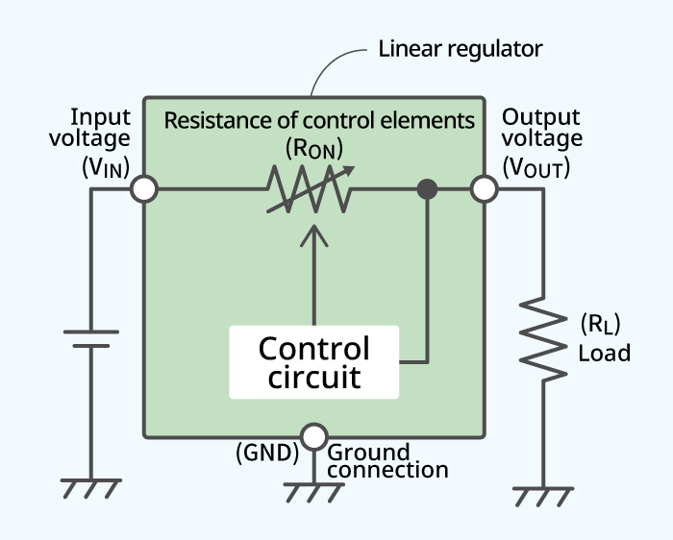A voltage regulator generates a fixed output voltage of a pre-set magnitude that remains constant regardless of changes to its input voltage or load conditions. There are two types of voltage regulators: linear and switching.

Figure 3.4 circuit diagram of regulator

A linear regulator employs an active (BJT or MOSFET) pass device (series or shunt) controlled by a high gain differential amplifier. It compares the output voltage with a precise reference voltage and adjusts the pass device to maintain a constant output voltage.

A switching regulator converts the dc input voltage to a switched voltage applied to a power MOSFET or BJT switch. The filtered power switch output voltage is fed back to a circuit that controls the power switch on and off times so that the output voltage remains constant regardless of input voltage or load current changes.

**33**

**3.2.2 ADVANTAGES OF REGULATORS:**

Some of the advantages of using regulators in bench grinding machine are

* Very accurate output voltage regulation.
* Wide choice of kVA rating, voltage and configuration.
* Easily applicable to outdoor application.
* High tolerance to system faults and overload.
* High tolerance to power factor and frequency deviations.
* Good line isolation.
* Relatively inexpensive.

**34**

**CHAPTER 4**

**CALCULATIONS OF THE MACHINE**

**4.1 BENCH GRINDING MOTOR:**

Bench Grinder is an electric motor with a shaft on the right and on the left, with a grinding wheel mounted each. The shafts should be as ball bearing as possible, so that they run perfectly and thus bring reasonable grinding results. A **bench grinder** is a [benchtop](https://en.wikipedia.org/wiki/Workbench) type of [grinding machine](https://en.wikipedia.org/wiki/Grinding_machine) used to drive [abrasive wheels](https://en.wikipedia.org/wiki/Grinding_wheel). A **pedestal grinder** is a similar or larger version of grinder that is mounted on a [pedestal](https://en.wiktionary.org/wiki/pedestal#Noun), which may be bolted to the floor or may sit on [rubber feet](https://en.wikipedia.org/wiki/Bushing_(isolator)). These types of grinders are commonly used to hand [grind](https://en.wikipedia.org/wiki/Grinding_(abrasive_cutting)) various [cutting tools](https://en.wikipedia.org/wiki/Cutting_tool_(machining)) and perform other rough grinding.

Depending on the bond and grade of the grinding wheel, it may be used for sharpening cutting tools such as [tool bits](https://en.wikipedia.org/wiki/Tool_bit), [drill bits](https://en.wikipedia.org/wiki/Drill_bit), [chisels](https://en.wikipedia.org/wiki/Chisel), and [gouges](https://en.wikipedia.org/wiki/Chisel#Gouge). Alternatively, it may be used to roughly shape metal prior to [welding](https://en.wikipedia.org/wiki/Welding) or fitting.

A [wire brush](https://en.wikipedia.org/wiki/Wire_brush) wheel or buffing wheels can be interchanged with the grinding wheels in order to clean or [polish](https://en.wikipedia.org/wiki/Polishing_(metalworking)) workpieces. Stiff buffing wheels can also be used when [deburring](https://en.wikipedia.org/wiki/Burr_(edge)#Deburring) is the task at hand. Some buffing machines (buffers) are built on the same concept as bench grinders except for longer housings and arbors with buffing wheels instead of grinding wheels.

**35**

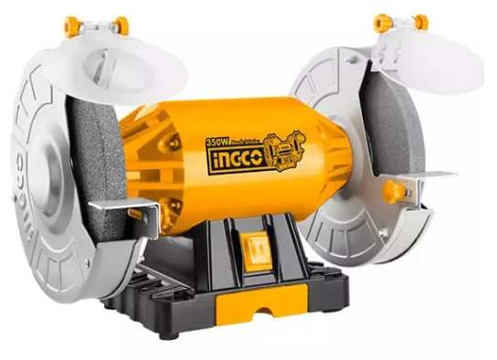Bench grinders are standard equipment in [metal fabrication shops](https://en.wikipedia.org/wiki/Metal_fabrication) and [machine shops](https://en.wikipedia.org/wiki/Machine_shop), as are handheld grinders

Figure 4.1 Bench Grinding Motor

An AC motor has been used for this bench grinding machine.

INGCO BG61502 motor with the specifications of

Rated input power – 150 W

Rated voltage – 220 – 240V

Wheel diameter – 150 mm

Non-load speed – 2950 rp/min

Weight – 5 kg

**36**

**4.2 SUPPORTING BASE:**

In this bench grinder a base has been fixed in order for the portability purpose of the machine. The dimensions of the supporting base are

Length – 30.5cm

Width – 30.5cm

Thickness – 3.5cm

Leg height – 79 cm

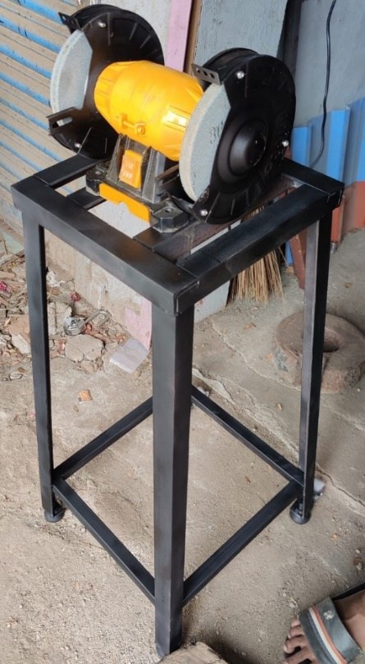Base Weight – 12 kg

Figure 4.2 supporting base

The supporting base has been fixed at a taper angle and the length and width of the bottom of the supporting base are

Length at base – 40.5cm

Width at base – 39.5 cm

**37**

**4.3 GRIT SIZE OF THE GRINDING WHEEL:**

The abrasive grit size range for grinding wheels runs between 12 grit for rough grinding operations, such as those found in steel mills, and 220 grit for very fine/precision grinding operations. Again, there is no industry standard, but in general terms: Coarse grits run 12 to 24.

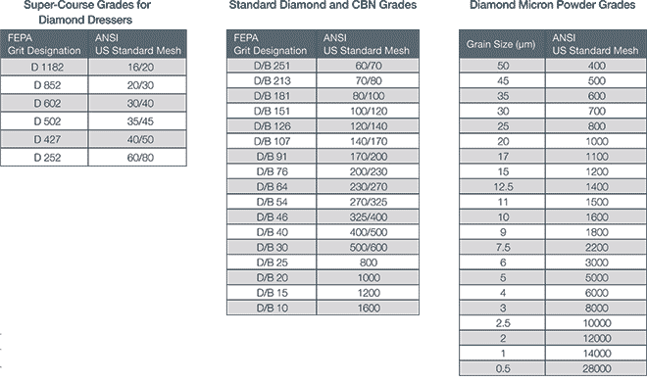32A46-**I**8VBE – The third part of the marking system identifies the grade or hardness of the wheel. The marking system uses letters between A and Z or ZZ to indicate how hard the wheel is. Each manufacturer may use the same marking system, but this does not mean that each manufacturer's particular grade is the same. We at Norton may have a mid-range wheel marked as a ‘J’ grade, and another manufacturer may also mark their wheel as a ‘J’ grade, but it doesn’t mean that they will be the same hardness or act the same. Generally, it just means that they are both mid-range wheels.

Table 4.3 Grit size of the Grinding Wheel Chart

**38**

For this project we have selected two grinding wheels for the grinding machine. The first type is coarse grinding wheel with less grit size for rough cutting and the other type is fine grinding wheel with more grit size for surface finishing.

* We used 24 grit coarse silicon carbide grinding wheel for rough cutting operations (150 or 6’)
* 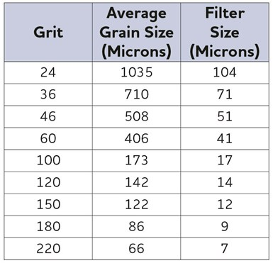We used 200 grit fine silicon carbide grinding wheel for surface finishing operations (150 or 6’)

Table 4.4 Grit values and their respected Sizes

**39**

**CHAPTER 5**

**CONCLUSION**

* By modifying the bench grinding machine, it can be useful with power

Consumption and can be utilized for various purpose like polishing, buffering, sharpening and shaping etc.

* When compared to the traditional bench grinding machines, our machine has the ability to regulate the speed so it will be a great use while machining.
* Unlike Traditional bench grinders, our bench grinding machine is mobile

And can be easily transported to any other locations

* By the addition of wheels the machine can be transported from one place to another place without any struggle.
* The traditional bench grinders are very heavy in weight when compared to our portable bench grinding machine. An actual bench grinding machine weighs up to 20 to 30 kg where as our bench grinding machine just weighs 5 kg and 15 kg even with the supporting base attached.
* By the addition of speed voltage dimming regulator we can adjust the speed of the motor easily from the least speed to maximum speed of the motor
* This dimmer regulator has the ability to control the speed in free manner while comparing to the other traditional regulator with step down speed controls.
* With this invention the need for taking the workpiece to the workshop frequently and the necessity is decreased because of the less weight and portability of the machine.
* This innovations further helps the people in various aspects by the regulation of speed.
* For example lightweight materials light aluminum or wood does not need the maximum rotational speed of the motor here regulation of speed comes in help by reducing the speed of the motor and machining.

**40**

|  |  |  |
| --- | --- | --- |
| **COST ESTIMATION** | | |
|  |  |  |
| **Sno.** | **Expenses** | **Amount Rs.** |
| 1 | Used Bench Grinding Motor | 2,500.00 |
| 2 | Materials for supporting base | 1,100.00 |
| 3 | labour charges for making supporting base | 400.00 |
| 4 | Wheels | 100.00 |
| 5 | Regulator/speed controler | 940.00 |
| 6 | Sheet metal for supporting base | 250.00 |
| 7 | Sheet metal for title and regulator attachment | 600.00 |
| 8 | Rubber bush | 150.00 |
| 9 | Labour charges for electrical connectivity | 200.00 |
| 10 | Coase grinding wheel | 400.00 |
| 11 | Fine grinding wheel | 900.00 |
| 12 | handle for supporting base | 300.00 |
| 13 | Spray paint for supporting base | 320.00 |
|  |  |  |
|  | **TOTAL** | 8,160.00 |

**41REFERENCE**

* Kanematsu, Y. and Satoh, Y., 2011. Influence of type of grinding stone on rail grinding efficiency. *Quarterly Report of RTRI*, *52*(2), pp.97-102.
* Crim, E.A. and Bradleyt, T.D., 1995. Measurements of air concentrations of thorium during grinding and welding operations using thoriated tungsten electrodes. *Health Physics*, *68*(5), pp.719-722.
* Marquardt, R.A. and McGann, A.F., 1975. Does advertising communicate product quality to consumers? Some evidence from consumer reports. *Journal of Advertising*, *4*(4), pp.27-31.
* Seligman, D.A. and Dawson, D.R., 2003. Customized heel pads and soft orthotics to treat heel pain and plantar fasciitis. *Archives of physical medicine and rehabilitation*, *84*(10), pp.1564-1567.
* Alley, C., 1958. Machine to disbud rootstocks: Adapted electric bench grinder facilitates disbudding grape cuttings before planting and avoids later growth of suckers. *California Agriculture*, *12*(7), pp.8-13.
* Struck, R.T., Zielke, C.W., Pell, M., Maskew, J.T., Sim, F., Rosenhoover, W.A. and Clark, W.E., 1980. *Zinc halide hydrocracking process for distillate fuels from coal. Volume I. Summary and continuous bench studies. Final report, January 1975-November 1979* (No. FE-1743-80 (Vol. 1)). Conoco Coal Development Co., Library, PA (USA).
* Bjoerkqvist, T., 1993. Modelling the grinding process. Final report; Hionnan mallintaminen; Loppuraportti.
* Mwansa, S., Dance, A., Annandale, D., Kok, D. and Bisiaux, B., 2010. *Integration and optimisation of blasting, crushing and grinding at the Newmont Ahafo operation*. Technical report.

**42**

* Cocco, C., Andriolo, J.L., Erpen, L., Cardoso, F.L. and Casagrande, G.S., 2010. Schuurmiddelen Bench Grinder slijpschijf voor 25A 1-125X29. 05X25. 4 A36p5V 35m/Sstrawberry plants as affected by crown diameter and plantlet growing period. *Pesquisa Agropecuária Brasileira*, *45*(7), pp.730-736.
* Raja, M.A. and Preethi, V., 2020. Photocatalytic hydrogen production using bench-scale trapezoidal photocatalytic reactor. *International Journal of Hydrogen Energy*, *45*(13), pp.7574-7583.
* Fernández Souza, L., 2016. Grinding and Cooking: and Approach to Mayan Culinary Technology. *Cooking Technology. Transformations in Culinary Practice in Mexico and Latin America*, pp.15-28.
* Pei, Z.J., Fisher, G.R., Bhagavat, M. and Kassir, S., 2005. A grinding-based manufacturing method for silicon wafers: an experimental investigation. *International Journal of Machine Tools and Manufacture*, *45*(10), pp.1140-1151.
* Tycova, A., Prikryl, J. and Foret, F., 2016. Reproducible preparation of nanospray tips for capillary electrophoresis coupled to mass spectrometry using 3D printed grinding device. *Electrophoresis*, *37*(7-8), pp.924-930.
* Hall, B.W., Singer, C., Jozewicz, W., Sedman, C.B. and Maxwell, M.A., 1992. Current status of the ADVACATE process for flue gas desulfurization. *Journal of the Air & Waste Management Association*, *42*(1), pp.103-110.
* Gülçur, S. and Firat, C., 2005. Spatial analysis of Güvercinkayası, a middle Chalcolithic hilltop settlement in northwestern Cappadocia: a preliminary report. *Anatolia antiqua. Eski Anadolu*, *13*(1), pp.41-52.

**43**

* Gülçur, S. and Firat, C., 2005. Spatial analysis of Güvercinkayası, a middle Chalcolithic hilltop settlement in northwestern Cappadocia: a preliminary report. *Anatolia antiqua. Eski Anadolu*, *13*(1), pp.41-52.
* Luckie, P.T., 1977. *Developing/modifying coal grinding procedures and equipment to produce predictable size distributions during coal preparation. Annual progress report, September 1976--September 1977* (No. FE-2475-13). Kennedy Van Saun Corp., Danville, Pa.(USA)
* Cai, T.D., Chang, K.C., Shih, M.C., Hou, H.J. and Ji, M., 1997. Comparison of bench and production scale methods for making soymilk and tofu from 13 soybean varieties. *Food research international*, *30*(9), pp.659-668.
* Wang, W., Li, J., Fan, W. and Zhao, C., 2022. Belt grinding mechanism-based method for roughness profile prediction of the rail surface. *Journal of the Brazilian Society of Mechanical Sciences and Engineering*, *44*(3), p.84.
* Kanematsu, Y. and Satoh, Y., 2011. Influence of type of grinding stone on rail grinding efficiency. *Quarterly Report of RTRI*, *52*(2), pp.97-102.
* García, E., Sánchez, J.A., Méresse, D., Pombo, I. and Dubar, L., 2014. Complementary tribometers for the analysis of contact phenomena in grinding. *Journal of Materials Processing Technology*, *214*(9), pp.1787-
* Amri, N.I.Q., 2022. The design of bench grinding machine using hard disk. Grinding is an important part of the final machining process.
* Zhu, D., Feng, X., Xu, X., Yang, Z., Li, W., Yan, S. and Ding, H., 2020. Robotic grinding of complex components: a step towards efficient and intelligent machining–challenges, solutions, and applications. Robotics and Computer-Integrated Manufacturing, 65, p.101908
* Lv, L., Deng, Z., Liu, T., Li, Z. and Liu, W., 2020. Intelligent technology in grinding process driven by data: A review. *Journal of Manufacturing Processes*, *58*, pp.1039-1051. - [Grinding](https://www.sciencedirect.com/topics/engineering/grinding-machining) is a key process in machining, which has direct impact on the accuracy

**44**

* Guzeev, V.I., Nurkenov, A.K. and Ignatova, A.V., 2015. Research stiffness of CNC plunge grinding machine units. *Russian Engineering Research*, *35*, pp.69-72.
* Ardashev, D.V., 2011. Standardization of grinding wheels. *Russian Engineering Research*, *31*(9), p.910.
* Champreux, J.P., Cahuc, O., Darnis, P., K’nevez, J.Y., Laheurte, R., Darbois, N., Néauport, J. and Albert, G., Design and development of a new mechanical actions measurement device for a glass grinding machine–Impact on SSD.
* Kuffa, M., Ziegler, D., Peter, T., Kuster, F. and Wegener, K., 2018. A new grinding strategy to improve the acoustic properties of railway tracks. *Proceedings of the Institution of Mechanical Engineers, Part F: Journal of Rail and Rapid Transit*, *232*(1), pp.214-221.

**45**